ISTANBUL TECHNICAL UNIVERSITY
COMPUTER ENGINERING DEPARTMENT

BLG 546E MACHINE LEARNING
CRN: 23438
Instructor: Tolga Ovatman

Report of Homework #1
March 18, 2017

Tuğrul Yatağan
504161551

Development, Build and Test Environment
Ubuntu 16.04.4 LTS Linux kernel 4.4.0-116-generic is used for build and test environment. Test system has 6 GB of RAM and 8 core i7-3632QM 2.20 GHz CPU. Oracla Java 8 is used for Java virtual machine. Following commands is used for installing Java virtual machine and IntelliJ IDEA:
sudo add-apt-repository ppa:webupd8team/java
sudo apt install oracle-java8-installer
sudo snap install intellij-idea-community -classic

Example screen shot of development environment:
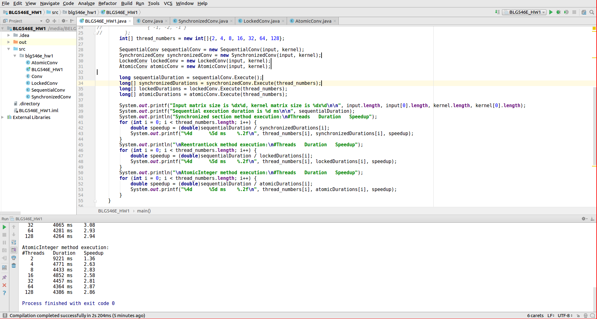
Example output:
Input matrix size is 10000x10000, kernel matrix size is 7x7
Sequential execution duration is 12522 ms
Synchronized section method execution:
#Threads Duration Speedup
2 7058 ms 1.77
4 3820 ms 3.28
8 3502 ms 3.58
16 3476 ms 3.60
32 3748 ms 3.34
64 3643 ms 3.44
128 3574 ms 3.50

ReentrantLock method execution:
#Threads Duration Speedup
2 6592 ms 1.90
4 4314 ms 2.90
8 3690 ms 3.39
16 4225 ms 2.96
32 3998 ms 3.13
64 4057 ms 3.09
128 4052 ms 3.09

AtomicInteger method execution:
#Threads Duration Speedup
2 6647 ms 1.88
4 3432 ms 3.65
8 3876 ms 3.23
16 4013 ms 3.12
32 4028 ms 3.11
64 3996 ms 3.13
128 4036 ms 3.10

Test Results
Execution time for sequential method, synchronized section parallel method, ReentrantLock parallel method and AtomicInteger parallel method are put in a chart. Also speedup factors for all methods are calculated in respect to sequential method.
Following tables shows that paralleling is good until number of threads exceeds number of cores. Maximum speedup on 8 core machine is 3.65x not 8x. Also speedup curve shape fits Amdahl’s Law.
Results shows that there is not much performance different between synchronized section parallel method, ReentrantLock parallel method and AtomicInteger parallel method.

Best execution time is 3432 ms

Best speedup factor is 3.65x

